Code Review: I2301221
Reviewer: James Wood
Date: April 13th, 2023
Bugs
- The function appears to only check the SO associated to the shipment header, but a Shipment may contain multiple SOs, using Batch Processor. Unfortunately, that means the complexity of this function must necessarily increase as you’ll have to go through the Details instead.
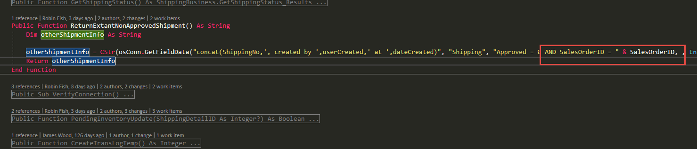
Preventative Action/Safety
Design/Architecture (Duplication, appropriate project, namespaces, maintainability)
Data Model(Naming, good design, needs index?)
Performance (Minimize DB hits, excessive loops, queries, scalable)
UI(Alignment, naming, standardization)
Error Handling(Behind events, appropriate parameter checking)
Cleanup (Dispose code, remove handlers, large data objects)
Readability (Well-named variables, methods, clear algorithm, is it understandable)
Comments (Useful, explains why rather than how)
Message Boxes (Grammar, spelling, captions, appropriate icons)
Ticket Management(Release Branch?, Testing Notes)
Extras
- Nit: This is a case of VB6 vs .Net style coding.
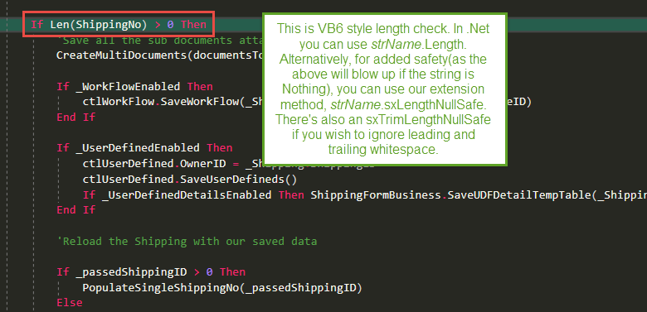

- Nit: Medley:
  - I would advise against using what some may perceive to be highfalutin language in code, when an otherwise common word would suffice or even no word at all:
    - ReturnExistingNonApprovedShipment vs ReturnNonApprovedShipment
This existing name is likely to confuse future devs.
  - It also looks like the function is based off the current shipment’s related SO, but the function name is fairly generic. This could be teased out based on knowledge of our business rules or by looking into the code, but if the function name could reflect this, all the better.
  - Be sure to press Ctrl K + D to auto-format/layout the code. The change has too many indents. Looks like it has been modified since.
  - Len() again. Use either .Length() or .sxLengthNullSafe()
- Good use of RequestMessageBox. We do not want message boxes displayed from system classes.
